4.5 Exercise 2 – carboxylic acids and esters

1. Write equations for the following reactions:

a) propanoic acid with sodium hydroxide
b) butanoic acid with sodium carbonate
c) sodium methanoate with hydrochloric acid
d) sodium ethanoate with sulphuric acid
e) 2-methylpropanoic acid with sodium carbonate

2. Write equations for the following reactions and name any organic products:

a) propanoic acid with methanol
b) ethanoic acid with propan-2-ol
c) methanoic acid with propan-1-ol
d) butanoic acid with butan-1-ol

3. Write equations, using displayed formulae, for the following reactions:

a) ethyl methanoate with conc. H₂SO₄
b) methyl propanoate with NaOH
c) methylethyl ethanoate with H₂SO₄
d) propyl methanoate with NaOH

4. Write equations for the reaction of the following oil:
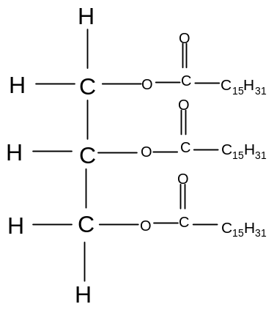
with
a) dilute hydrochloric acid in the presence of lipase
b) sodium hydroxide

Suggest where each of the reactions might take place and state a use for each of the products in each case.

